

**T : +604 294 3755  
 E :** [thfgrants@habitatfoundation.org.my](mailto:thfgrants@habitatfoundation.org.my) **W:** [http://habitatfoundation.org.my](http://habitatfoundation.org.my/)

**488A-20-02 & 03, Penas Tower  
One Stop Midlands Park Complex  
Jalan Burma, 10350 Pulau Pinang, Malaysia.**

Project Title:

**THF GRANT   
CONCEPT PROPOSAL**

Applicant’s Name:

Organisation:

Date:

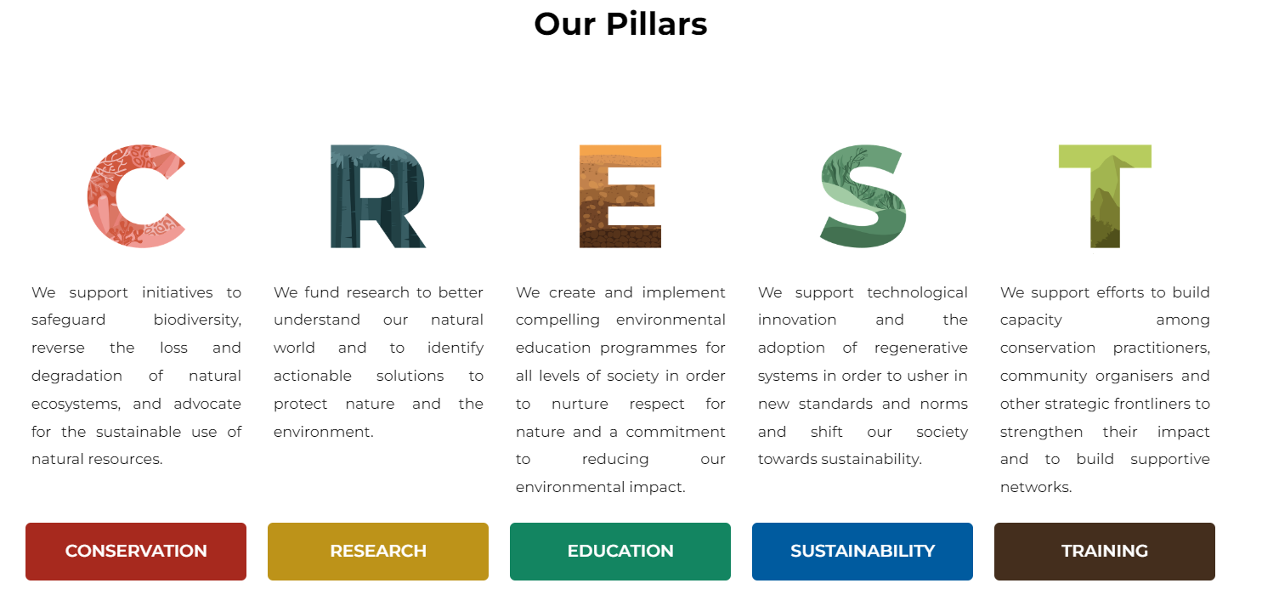The Habitat Foundation Grants are awarded to individuals and organisations dedicated to biodiversity conservation and sustainability across these five pillars which form the focus of our programme: **Conservation**, **Research**, **Education**, **Sustainability**, and **Training**.

THF Grants provide an opportunity for academicians, students, researchers, community members, trainers and environmental practitioners to advance their work in the above-mentioned areas. The goal is to strengthen species protection, enhance protected area management, and build capacity for sustainability and environmental education in all its forms.

THF Grants are awarded to individuals and organisations that are striving them to make a impact within the different pillars. We welcome applications from a diverse array of projects and initiatives that have the potential to make strategic and significant contributions for the betterment of our planet.

Whether the work focuses on **conservation** initiatives, cutting-edge **research**, innovative **educational** programmes, **sustainability**-driven projects, or **training** efforts, THF Grants are designed to facilitate and accelerate progress. The Habitat Foundation recognises that change comes from different disciplines and perspectives. We embrace collaborative approaches to preserving our natural heritage and safeguarding a future for all life.

**Important Notes:**

1. **Concept Proposal/Application Form**
   1. There are four (4) section to this Concept Proposal (application form).
   2. Please read and understand carefully all questions and fields in this form.
   3. All **required (*) fields** are expected to be answered by the applicants.
   4. Please **upload all necessary attachments by labelling it clearly** as stated in Section 4 in a **WeTransfer/Dropbox/Google Drive folder and share/paste the link** in Section 4.
   5. THF Grants **only support** projects that are carried out in Malaysia only.
   6. Do not exceed the word limit that has been set upon.
   7. Only shortlisted Concept Proposals will be invited to submit a full proposal.
   8. Incomplete forms will be disregarded by The Habitat Foundation.
   9. Text in ***italics* and *grey* in colour** is explanatory (to assist you). You may **delete it** in the completed documents
2. **Grantees Guidebook**Make sure to download the **Grantees Guidebook**, your essential resources containing all the information and valuable tips you need to become our successful grantee.
3. **Submission of Application**Applicants to submit this application form by email to [thfgrants@habitatfoundation.org.my](mailto:thfgrants@habitatfoundation.org.my) before **July 31, 2023**.
4. **For Any Assistance** Shall you face any trouble answering this form or downloading the Grantees Guidebook, reach us via **email at** [thfgrants@habitatfoundation.org.my](mailto:thfgrants@habitatfoundation.org.my)or **call us at +604 294 3755** for assistance.

|  |  |  |  |
| --- | --- | --- | --- |
| **SECTION 1: APPLICANT DETAILS** | | | |
| **Name\***  *(as per NRIC/ Passport)* |  | | |
| **Position**  *(If applicable)* |  | | |
| **Organisation\*** |  | | |
| **Address\*** |  | | |
| **Telephone/Mobile\*** |  | **Email\*** |  |
| **Website:** *(Optional)* |  | | |

|  |  |  |
| --- | --- | --- |
| **SECTION 2: PROJECT DETAILS** | | |
| **Project Title \*** |  | |
| **Pillars**  *Please tick the two options that are most relevant. Refer to Grantees Guidebook for more information on pillars.* | Conservation  Research  Education  Sustainability  Training | |
| **Project Summary \***  *Please describe how you will use the grant funds to address a particular issue and explain the expected outcomes. Limit your response to 500 words.* |  | |
| **Location \***  *E.g. Kuala Selangor Nature Park, Selangor and Mersing, Johor* |  | |
| **Name of Project Lead \***  *Please provide the name of the individual who will be leading the project.* |  | |
| **Project Lead’s Mobile\*** |  | |
| **Alternative Contact Person** |  | |
| **Alternative Contact Person Mobile** |  | |
| **Project Partners and Beneficiaries \***  *E.g. Name of NGO, agency, community* |  | |
| **Experts and Advisors (if applicable):**  *E.g. Name of involved individuals* |  | |
| **Project Timeframe \*** | **Total Months: \*** | **From: \***  **To: \*** |
| **Amount Requested (in MYR)\*** |  | |

|  |
| --- |
| **SECTION 3: PROJECT DESCRIPTION**  *The total word count for this section should not exceed 2,000 words.* |
| **\*Project Location/Site:** *Please specify the geographical location where the project will be conducted.*  *(50 words)* |
| **\*Project Background:** *Please provide information on the objectives of the project and the significance of the area and/ or the specific issue(s) that will be targeted or addressed by the project.*  *(300 words)* |
| **\*Experience in the Area:** *Please describe the duration of your previous involvement in this particular area and the rationale for the proposed project.*  *(300 words)* |
| **\*Project Activities and Implementation:** *Please provide a description of the activities that will be carried out to achieve the project objectives. Include the project timeframe, milestones, and the individuals or organizations involved in the implementation. You may use bullet points.*  *(350 words)* |
| **\*Describe the involvement of partners, authorities, and stakeholders in grant utilisation, highlighting their contributions and collaborations to enhance project outcomes.**  *(300 words)* |
| **\*What is the intended impact of the project?**  *(300 words)* |
| **\*How will the project's intended impact be sustained over time?**  *(300 words)* |
| **Please provide any additional relevant information or details related to your project.**  *(100 words)* |

|  |
| --- |
| **SECTION 4: PROJECT PHOTOS AND DOCUMENTS**  *Photos: Minimum file size of 5MB; Documents: Maximum file size of 20MB* |
| **File Naming Convention:**  (Keywords of your project)_(Acronym of your name)_(Type of photo/document)  **Examples:**  E.g. Orchid Penang Hill_RPC_ProfilePic 2  Odonoata PHBR_CCY_Subject 1  WoW Langkawi_MareCet_WIP 1  Paludiculture Sarawak_MARDI_Proposal  *Please organise all relevant photos in a folder and provide a folder link for the digital images. You can share these with us using WeTransfer, Dropbox, or Google Drive. You can paste the specific link for each photo below.* |
| **Applicant's Profile Picture\***  *(Refer to the communication section of the Grantees Guidebook; minimum 3 photos)*  Link: |
| **Photos of the Subject and/or Site of Interest\***  *(Refer to the communication section of the Grantees Guidebook; minimum 3 photos)*  Link: |
| **Relevant Supporting Documents**  *E.g. proposal, journals, reports, and approvals from authorities*  Link: |
| **Work-in-Progress Shot**  *(Refer to the communication section of the Grantees Guidebook; minimum 3 photos)*  Link: |
| **Project Logo** *(if applicable)*  Link: |
| **Social Media Handles**  *E.g. @TheHabitatFoundation, wherever applicable*  Facebook: Instagram:  LinkedIn: YouTube:  Twitter: Tik Tok:  Others: |